Task 1:

a) Write a query to retrieve student details, such as student name, contact informations, and Enrollment status.﻿

Output :

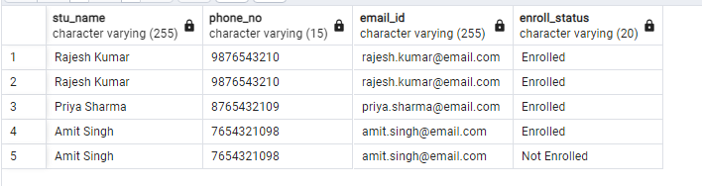

b) Write a query to retrieve a list of courses in which a specific student is enrolled:

Output:

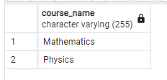

c) Retrieve course information, including course name and instructor information:

Output:

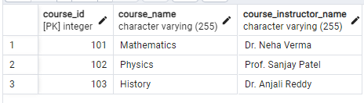

d) Retrieve course information for a specific course:

Output:

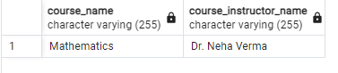

e) Retrieve course information for multiple courses

Output:

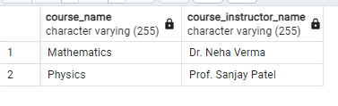

Reporting and Analytics

a) Write a query to retrieve the number of students enrolled in each course

Output:

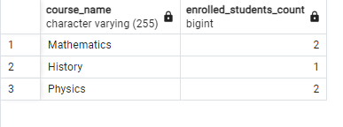

b) Retrieve the list of students enrolled in a specific course

Output:

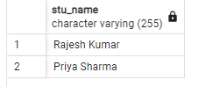

c) Retrieve the count of enrolled students for each instructor:

Output:

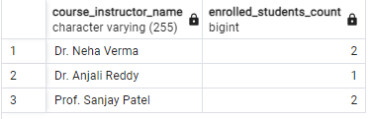

d) Retrieve the list of students who are enrolled in multiple courses:

Output:

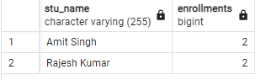

e) Retrieve the courses with the highest number of enrolled students, arranged from highest to lowest:

Output:

